

Mental Health Management Plan

Introduction:
This Management Plan is intended to govern business activities in managing mental ill-health and promote the well being and welfare of the people working at and for AMH Civil.
The Management Plan will document strategies, procedures and actions in accordance with the three areas nominated by the National Workplace Initiative Blueprint for Mentally Healthy Workplaces:
- Protect – Identify and manage work related risks to mental health
- Respond – Build capability to identify and respond to support people experiencing mental ill-health or distress
- Promote – Recognise and enhance the positive aspects of work that contribute to good mental health

Interested Parties
This Management Plan applies to all AMH Civil workers and contractors.

Relevant Standards:
National Workplace Initiative Blueprint for Mentally Healthy Workplaces
Refer to references at end of document for other literature sources used in the development of this plan.

Mandatory Training Requirements
Mental Health First Aid training – St Johns or other approved training body

Change | Authorised By | Date
Issued for consultation | J Mansell | 12/7/2022

Contents
1. Definitions 3
2. Protect 4
2.1 The right to a healthy, safe workplace 4
2.2 Workplace Psychosocial hazard assessment: 6
2.3 Implementation: 8
2.4 Employee Responsibilities 9
2.5 Employer Responsibilities 10
2.6 Staying at work or taking leave 10
3. Respond 12
3.1 Responding to Events 12
3.2 Category A Events 12
3.2.1 Category A immediate response 12
3.2.2 Category A follow up response 13
3.3 Category B Events 13
3.3.1 Category B response: 13
3.4 Category C Events 14
3.4.1 Category C response 14
3.5 Category D Events 15
3.5.1 Category D Response 15
3.6 Confidential Discussion and Referral Guidelines 15
3.7 Mental Health and Personal Issues Referral Matrix 17
4. Promote 19
4.1 Keeping the team healthy 19
4.2 Five Ways to Wellbeing 19
5. References: 21

Definitions
The following terms will be used throughout this document with the definition provided below.
Mental Health: A positive concept and more than just the absence of illness. In this Management Plan, the term mental health is used to refer to a state of wellbeing where a person can realise their own potential, can cope with the normal stresses of life, can work productively and fruitfully and is able to contribute to their community.
Mental Ill-health: A term that encompasses both mental illness and changes in emotion or behaviour that can impact a person’s cognitive, emotional or social abilities but not to the extent that it meets the criteria for a mental illness diagnosis. These changes can result from life stressors and often resolve with time or when the person’s situation changes. These changes may develop into a mental illness if they persist or increase in severity.
Mental Illness: A disorder diagnosed by a health professional that significantly interferes with a person’s cognitive, emotional and/or social abilities. Mental illness can vary in both severity and duration. The term mental illness is used to refer to a wide spectrum of diagnosable conditions that affect how a person feels, thinks, behaves, and interacts with other people.
Psychosocial Hazard: Psychosocial hazards at work are aspects of work and situations that may cause a stress response which in turn can lead to psychological or physical harm.
Mentally Healthy Workplace: Describes workplace experiences that protect, respond to and promote mental health.
Lived experience: Refers to people who have either current or past experience of mental ill-health or a carer
Mental Health and Personal Welfare Event: Any report, incident, disruption or disturbance of a person’s Mental Health or Personal Welfare that requires or requests workplace intervention or support.
Mental Health First Aider: Someone suitably trained and nominated by AMH Civil management as a first responder to Mental Health or Welfare events or reports within the workplace.

Protect
This section will document how AMH Civil aims to identify and manage work related risks to Mental Health.

The right to a healthy, safe workplace
Under Victorian Occupational Health and Safety legislation, AMH Civil is obligated, so far as is reasonably practicable, to provide a safe and healthy workplace.
This means steps must be taken to ensure that the working environment does not harm mental wellbeing or aggravate an existing condition.
AMH Civil will work to create a positive, supporting, and trusting working environment to prevent risks to the health and safety of employees.
Through the implementation of this management plan, AMH Civil will identify, prevent and lessen potential mental health risks to the health and safety of employees.
The below graphic introduces the context of mental health risks and hazards by dispelling some common misconceptions around the impacts and extent of mental health hazards and risks in a work environment.
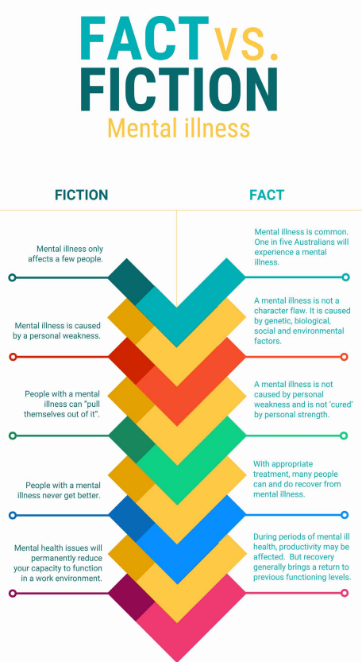
Figure 1 - Source: blackdoginstitute.org Mental Health Toolkit

Workplace Psychosocial hazard assessment:
In order to manage potential risks and hazards relating to mental health, AMH Civil will:
- Assess, describe and document potential risks and hazards through consultation with employees at Prestarts, annual reviews, and informal discussions
- Consult with relevant government bodies, statutory authorities and industry bodies to identify other risks and hazards
- Develop proposed mitigation measures at a business level to prevent or reduce the impact of the identified hazards
- Assign responsibilities for implementation and monitoring of the mitigation measures
- Regularly review the Psychosocial Hazard Assessment to ensure currency
The Psychosocial risk assessment is as below:
Hazard | Mitigation measures | Responsible Party
Personnel feel excluded or alienated from work culture as a result of onboarding failure | Clear onboarding process (including documented induction) developed to provide information on direct reports, points of contact  Clear reporting structure / Org Chart in place to ensure new personnel know who to report to, with line manager responsible for introductions and welcoming | General Manager  Operations Manager  Line Managers
Personnel feel overwhelmed by work tasks as a result of insufficient training or experience | Clear recruitment strategy in place to screen new employees for skills and experience relevant to planned roles  Clear processes, checklists, and training manuals in place and accessible to personnel to ensure clarity of task requirements  Org Chart in place with sufficient Supervision or Line Managers to provide further support or training as required  Employee Performance and Discipline procedure used to manage performance issues through the Just Culture Framework to eliminate fear in the organisation | General Manager  Operations Manager  Project Managers  Supervisors
Personnel feel overwhelmed by work tasks as a result of poor resourcing | Recruitment and resourcing requirements reviewed and discussed at Weekly and Monthly meetings/reports.  Project handover process identifies skills or resource gaps  Project Delivery Manual and other training manuals identify standard resourcing required for works  Org Chart with sufficient line managers in place to provide support, request support, and report up resourcing issues | General Manager  Operations Manager  Project Managers  Supervisors
Personnel feel uncomfortable as a result of poorly maintained or insufficient site facilities | Business to set clear expectations on minimum standards of site facilities  Refer to:  Safety Management Plan  Site Facilities Adequacy Checklist | General Manager  Operations Manager  Project Managers  Supervisors
Personnel feel unsafe as a result of poor work practices | Policy and management plan to ensure safe work practices are planned and implemented.  Refer to:  Workplace Health and Safety Policy  Safety Management Plan  Other IMS documents as relevant | General Manager
Bullying or harassment within the workplace | Policy development prevents and manages bullying and harassment. Personnel trained onto policies through induction.  Refer to:  Workplace Health and Safety Policy  Employee Support Policy  Technology Fair Use Policy  Diversity and Equal  Opportunity Policy  Standard Procedure for Employee Performance & Discipline, and Just Culture framework | General Manager  Employees
Mental Health or Welfare event occurs on site | Management plan developed to document strategies to mitigate including Mental Health First Aid training, and Response Framework in Section 3 of this plan. | General Manager  Operations Manager  Mental Health First Aiders
Mental Health or Welfare issue reported to staff | Management plan developed to document strategies to mitigate including Mental Health First Aid training, and Response Framework in Section 3 of this plan. | General Manager  Operations Manager  Mental Health First Aiders
Workplace fatigue | Fatigue management and Fitness For Work policies implemented  Annual Leave and Personal Leave encouraged where required  Refer to:  Safety Management Plan  Fitness for Work Policy | General Manager  Operations Manager  Line Managers
Extended periods of unplanned leave lead to feelings of isolation, or contribute to mental ill-health | Personal Leave to be managed in accordance with the guidance of this management plan  Return to work plans or alternate work arranged to keep personnel in work if they are deemed fit to do so | General Manager  Operations Manager  Line Managers

Implementation:
Development and implementation of the management plan will follow the steps below to ensure continuous improvement and active consultation with work groups in the business.
Consult and listen
Active reporting and monitoring of issues and concerns across work crews and Supervisors initiates discussion around improvements required for mental health management including an articulated and documented strategy.
Engage decision makers early
General Manager and Operations Manager initiate need for formal management plan to be developed
Link action to outcomes
Arrange formal Mental Health First Aid training. Discuss internally to agree follow up actions.
General Manager to track implementation of management plan and monitor reporting of mental health related issues or events.
Assign accountability
Nominate personnel with relevant training and experience to be Mental Health First Aiders for leadership of mental health discussions and responses throughout the business.
Integrate into business as usual
Mental Health First Aiders to be existing personnel with leadership skills where possible to ensure integration through the existing team.
Make changes visible and transparent
Roll out management plan document, and describe in detail its contents. Share document on OneDrive and on sites where possible for availability and transparency.
Base decisions on research-supported approaches
Continuous review by management of state and federal government guidelines and codes of practice where available.
Continually review and approve
Review outcomes of incident records to identify improvements. Report feedback from Prestarts, Checklist submissions and Whatsapp discussion forum to improvements or changes. Make changes through discussions with workforce and leadership team including MHFA’s.

Employee Responsibilities
Excerpt from blackdoginstitute.org.au
If your mental health condition does not affect how you do your job, you have no legal obligation to tell your employer about it. This applies whether you are a current employee, or a potential employee going through the recruitment process.
WH&S laws protect your right to a safe workplace, but you also have responsibilities under the same legislation. You must take care of yourself and others and cooperate with your employer in matters of health and safety. This applies to all workers, whether they have a disability or not. As well as this, under the Disability Discrimination Act 1992 (Cth) your ability to work safely is an ‘inherent’ or essential requirement of any job. If your disability could reasonably be seen to create a health and safety risk for other people at work, then your failure to tell anyone about that risk could be a breach of your obligations under WH&S legislation.
There is no obligation to tell your employer about a mental health condition if it does not affect how well you do your job. You need to tell your employer when your mental health condition:
- affects how you carry out the inherent requirements of your job. In this context, the purpose of providing the information is to enable your employer to identify reasonable adjustments that might assist you to perform your role.
- affects your health and safety and/or the health and safety of colleagues
- is affected or could be affected by the nature of your work
A failure to disclose a mental illness may disentitle an employee to workers compensation should they suffer any recurrence, aggravation or exacerbation of a pre-existing mental illness.

Employer Responsibilities
Excerpt from blackdoginstitute.org.au
Generally, employers have a positive obligation to make reasonable adjustments for employees and prospective employees experiencing a mental illness.
Making reasonable adjustments to work for someone experiencing a period of mental ill health is a legal obligation of all employers and can greatly assist the employee in remaining at work. A failure to make reasonable adjustments for an employee or prospective employee experiencing mental illness can constitute discrimination. Reasonable adjustments are changes to a job, which can be made to enable a worker to perform their duties more effectively. Employers are required to make reasonable adjustments for workers experiencing a mental illness, unless:
- the employee could not or cannot adequately perform the inherent requirements of the employment even after the adjustments are made
- making the adjustments would impose an unjustifiable hardship on the employer.
Reasonable adjustments can include changes to the work environment, the work you do, your workload or hours, or the amount of supervision and support you need.

Staying at work or taking leave
Excerpt from blackdoginstitute.org.au
It may seem logical to think that time off work is the best solution for anyone with a mental health issue, but in fact this is not always the case. Most people with mild to moderate mental health issues can function at work, perhaps with some reasonable adjustment to their duties, and benefit from being there. The benefits include:
- remaining part of a larger whole (belonging is an important component of resilience)
- avoiding isolation at home
- maintaining some productivity and sense of achievement
- providing a healthy distraction
- maintaining a routine
- better monitoring of progress
- visible support from peers and management
- resolution of precipitating and exacerbating issues in the workplace, leading to less ‘mental scar tissue’ relating to the work situation
- avoiding the need for a return to work after a period of absence, during which fears about the likely reactions of others may have developed or misperceptions may have increased
- increasing commitment to the organisation in that its efforts to assist are clearly visible
An employee should not stay at work when s/he is:
- at risk of self-harming or suicidal behaviour
- a danger to others. The organisation has a duty of care to all of its employees and should a person’s mental illness result in behaviour that poses a risk to others, s/he should not remain in the workplace until the episode is contained
- showing signs of psychosis (e.g. delusions of grandeur, paranoia, hearing voices etc)
- is suffering from very deep depression, often characterised by psychomotor slowing, which severely impacts upon concentration, motivation, productivity and capacity to control emotions
- very agitated and is unable to control emotions
- behaving in a way that is significantly affecting other employees and reasonable adjustment is impossible or does not improve the situation

Respond
This section of the management plan aims to document how the business will build capability to identify and respond to support people experiencing mental ill-health or distress

Responding to Events
AMH Civil will ensure sufficient personnel have been trained in Mental Health First Aid to manage events in the workplace.
AMH Civil Senior Management will consult and nominate appropriate personnel for Mental Health First Aid training and to become workplace Mental Health First Aiders.
AMH Civil will make clear the responsibilities and obligations of Mental Health First Aiders through this management plan.
AMH Civil will ensure that people nominated as Mental Health First Aiders are supported and equipped with the tools required to discharge their obligations and responsibilities through this management plan.
AMH Civil will notify the workforce of the designated and trained Mental Health First Aiders (MHFA) within the team, and clarify their role and purpose.
AMH Civil will communicate employee obligations and responsibilities to report Mental Health or Personal Welfare events as required under law.
Mental Health and Personal Welfare events will be identified, triaged, and responded to using the framework below but at the reasonable and lawful discretion of the MHFA responsible.
AMH Civil will support event response and follow up using the established business Organisational Chart
AMH Civil will maintain a supportive and positive culture to ensure proactive reporting of Events

Category A Events
- I am at immediate risk of harm / Someone on site is at immediate risk of harm
- I am having suicidal thoughts or considering self-harm
- Someone has reported to me they are having suicidal thoughts or considering self-harm
- Someone has reported to me they are experiencing a severe attack of anxiety or depression
- Someone has reported to me they are experiencing chest pains
- I am experiencing a severe attack of anxiety or depression
- I am experiencing chest pain

Category A immediate response
- Take the affected person to a safe and isolated area if possible (crib sheds, a closed office etc)
- Call an ambulance and follow advice from emergency services
- Contact a nearby Mental Health First Aider if available to take over the situation
- Notify the Operations Manager

Category A follow up response
- Operations Manager to ensure affected person receives follow up medical review from a General Practioner
- Person to obtain a statement of capacity from the GP
- Operations Manager to consult confidentially with the person and the directions of the GP to develop a Return to Work Plan
- Operations Manager to de-brief any witnesses of incident or event on site. This may be in the form of a team meeting, or several one-on-one discussions. Operations Manager will be discrete and not divulge personal, private and information held in confidence during de-briefs, instead only focussing on the witnessed facts and the witnesses feelings and impressions.
- Operations Manager to refer to Category B or C event management where relevant during debriefs

Category B Events
- I am concerned about my behaviour or mental health at work
- I am concerned about someone else’s behaviour or mental health at work
- Someone has reported to me that they are feeling anxious or depressed
- I am concerned about my own personal use of drugs and alcohol
- I am concerned about someone with potential substance abuse issues
- I am a victim of domestic violence
- I am concerned about my behaviour at home
- Someone has reported to me they are acting violently or aggressively at home
- Someone has reported to me they are subject to violence or aggression at home
- I am being bullied or threatened at work
- Someone is being bullied or threatened at work
- I have witnessed a traumatic event or incident inside or outside of work

Category B response:
- As the above scenarios directly affect persons within the workplace in some form these issues must be reported
- Refer to Category A response if issue becomes life threatening, or if immediate risk of harm is likely to occur
- Report confidentially to Mental Health First Aider (MHFA), or to the Operations Manager
- MHFA must confidentially report the matter to the Operations Manager or the General Manager for the matter to be logged on the confidential Mental Health Incident and Report Register. This will ensure follow up.
- MHFA to request confidential discussion with affected person at an agreed time and location, preferably during working hours and at the workplace but in a discrete setting
- MHFA to conduct confidential discussion in accordance with the Confidential Discussion and Referral guidelines below
- MHFA to review notes and outcomes of confidential discussion and decide the following:
  - Is a Category A response required? If so, refer to Category A response. Category B response may be pursued following outcome of Category A response (ie following hospital discharge)
  - Is the person capable of performing their usual duties? If not, advise person to consult a General Practioner to make a plan and confirm capacity for work
  - Is leave required? Support person through discussions with Operations Manager or General Manager to understand leave options and return to work options
  - If the person is capable of performing their usual work duties, and the person does not require escalation or further immediate support, refer the person to one or two relevant support services listed in the Mental Health and Personal Issues Referral Matrix below.
  - Discuss with the person what actions, if any, could or should be taken by the person in the short term. Document any actions arising if appropriate.
  - MHFA to report and refer outcomes and next steps required to Operations Manager or General Manager confidentially for logging and follow-up. OM or GM to follow up with the person any medical advice or counselling plans resulting from the discussion.
  - Follow up with the person the next day informally to check if OK. Follow up with the person in one week with a formal conversation and repeat the Category B response steps.
  - MHFA to seek support from Operations Manager, General Manager, or other MHFA independently as required through Category B, C, or D response plans

Category C Events
- I am feeling anxious or depressed
- I am struggling with personal issues at home
- Someone has reported to me they are struggling with personal issues at home
- I am struggling with current work load or work pressure
- Someone has reported to me they are struggling with current work load or work pressure

Category C response
- Note that you are not obliged to report Mental Health issues unless you feel it is affected your work or your workplace
- AMH Civil preference is for issue to be reported to Mental Health First Aider (MHFA) or to the Operations Manager for support
- MHFA to conduct confidential discussion in accordance with the Confidential Discussion and Referral guidelines below
- MHFA to identify if the issue should be considered for Category A or Category B response and act accordingly
- MHFA should ask the person what support they require
- MHFA to refer the person to one or two relevant support services listed in the Mental Health and Personal Issues Referral Matrix below
- MHFA to discuss with the person what actions, if any could or should be taken by the person in the short term, or if any reports need to be made to Senior Management for further support.
- MHFA to ask the person if they require the issue to be reported for follow up by Senior Management, and if so, to make such a report noting details and possible courses of action
- If reported by MHFA - General Manager / Operations Manager will offer confidential support to the person with reference to the Employee Support Policy, and to potentially investigate any workplace related root causes and possible remedial actions.

Category D Events
- I am interested in further information on mental health and its potential forms and impacts
- I am interested in becoming a Mental Health First Aid responder
- I am concerned about someone else’s mental health
- Someone has asked me for non-urgent help regarding a mental health or wellbeing issue

Category D Response
- These events do not require formal reporting
- Person may speak directly to a MHFA or Senior Management about the above matters
- MHFA to discuss informally with the person and make reference to this management plan for further information and advice.
- MHFA to consider if independent follow up of others persons is required to ensure they are OK, and to follow up with a confidential discussion if required with reference to Category A, B or C responses above.

Confidential Discussion and Referral Guidelines
Consider the environment:
- Is it free of interruptions?
- Is it quiet?
- Is it safe?
- Is it private?
- Is it reasonably comfortable?
Consider yourself:
- Are you distracted?
- Are you able to remain focussed?
- Are you in a good frame of mind?
- Is there something you need to do or could do to clear your head prior to engaging in this conversation?
- Do you have the confidence and trust of the person? Do you have a professional relationship with them? If not, ask person if they would prefer referral to a different MHFA in the business.
- Are you prepared for an emotional response including tears, withdrawal, defensiveness etc?
Consider the person you are meeting:
- If this is a follow up meeting, are there any commitments or actions to follow up (you or them)?
- What more might they need to feel comfortable?
- Are they displaying obvious signs of anxiety or distress?
- Do they need a glass of water?
Initiate the discussion
- Reassure them that the conversation is held in confidence. Clarify that you are both obliged to report some serious matters as noted above, but that reporting can be done discretely and confidentially.
- Share any concerns you might have as observations, using non-judgemental language and expressions eg. “You seem anxious lately. Are you okay?”
- Ask open ended questions that give the person a way to safely disclose their concerns or issues eg. “How are you feeling at work?”, “How are things at home?”, “What made you want to speak with me today?”
- Listen intently
- Avoid giving advice
- Take the matter seriously
- Use a calm and reassuring tone
- Acknowledge how hard it must be for the person to talk about
- Be aware of cultural and linguistic differences
- Ask how you can help
- Express to them if you feel concerned for their safety
The main thing is to listen for imminent danger or risk, and to listen generally. Sometimes people just need to talk.
During the discussion do not:
- Assume any facts before you’ve had the conversation
- Ask overly direct or insensitive questions
- Express doubt, shock or judgement
- Criticise their decisions or other people involved in the conversation
- Attempt to “fix” their situation directly
At the end of the conversation, refer to the response guidelines above and the referral matrix below to provide some support suggestions. If you need to make a report, tell them. Provide them with the opportunity to report as well, but not in lieu of your own report.
In reporting, only report simple facts and proposed response actions. Personal details are not required unless contributing to some imminent danger or risk.

Mental Health and Personal Issues Referral Matrix
Response Category | Issue | Provider name | Contact | Cost
A | Someone’s life is in danger or there is an immediate risk of harm | Ambulance Victoria | 000 | Free
A |  | Poisons Information Hotline | 13 11 26 | Free
B | GP consultation required to discuss mental health and capacity for work | Medical clinic on nearest emergency response plan  OR  Northern Health Epping | As per emergency response plan  OR  1300 874 243  Northern Hospital  185 Cooper Street  Epping 3076 | Some costs may apply
 | General information, resources and help | Head to Health | headtohealth.gov.au | Free
 | General information, resources and help | Beyond Blue | 1300 22 4636  beyondblue.org.au | Free
B | Urgent counselling and support | Lifeline Australia | 13 11 14  lifeline.org.au | Free
B | Support relating to suicide | Suicide Call Back Service | 1300 659 467  suicidecallbackservice.org.au | Free
B | Support related to domestic violence | 1800 Respect | 1800 RESPECT  www.1800respect.org.au | Free
B | Support related to domestic violence | Safesteps Family Violence Response Centre | 1800 015 188  www.safesteps.org.au | Free
B | Support for men:  - Managing anger  - Managing fatherhood  - Managing a relationship  - Domestic violence | MensLine Australia | 1300 78 99 78  mensline.org.au/ phone-and-online-counselling | Free
B | Support for eating disorders | Butterfly Foundation | 1800 334 673  butterfly.org.au | Free
B | Support related to drugs and alcohol | Counselling Online | counsellingonline.org.au | Free
C | Support for 12 – 25 year olds | headspace Australia | 1800 650 890  headspace.org.au | Free
C | Support for LGBTI communities | QLife | 1800 184 527  qlife.org.au | Free
C | Support for marriages and families | Relationships Australia | 1300 364 277  relationships.org.au | Free
C | Support for carers | Carers Australia | 1800 422 737  carersaustralia.com.au | Free
C | Support for people with diagnosed complex mental health issues | SANE | 1800 187 263  sane.org | Free
C | Support for people in financial difficulty | National Debt Helpline | 1800 007 007  ndh.org.au | Free
C | Support related to gambling | Gambling Help Online | 1800 858 858  gamblinghelponline.org.au | Free
C | Support for Aboriginal and Torres Strait Islander people | Wellmob | wellmob.org.au | Free

Promote
This section of the plan documents ways to recognise and enhance the positive aspects of work that contribute to good mental health.

Keeping the team healthy
Excerpt from blackdoginstitute.org.au
If you’re a team leader or a team member, there are things you can do to promote mental health and wellbeing.
Research shows that the way our jobs are designed, our organisations are structured and function, and the support we receive in the teams where we work are important factors in developing a mentally healthy workplace.
Here are some things you can do:
- if you’re a team leader, build an ongoing feedback loop. Take time to have regular, informal conversations with each member of your team. Regular feedback rather than the ‘Annual Review’ is more likely to help them feel valued. It also allows you more opportunity to get to know them as persons, and makes it more likely that you will a) notice changes in behavior and performance earlier on if they arise and b) feel more comfortable asking about their wellbeing and mental health.
- everyone benefits by being clear about their role. A key component of workplace stress is a lack of role clarity. Find regular opportunities to discuss tasks and what’s expected.
- encourage trusting and respectful communications. Always hold sensitive conversations in places that provide privacy and respect.
- make work meaningful. Having regular conversations about how person roles contribute towards the overall direction of the organisation can help people feel more connected.
- set the standard. If you witness or hear behaviour or conversations that are inappropriate, intervene promptly.
- be aware of the behaviour you model and the messages you send – whether you are a team leader or a team member – both in what you physically do and how you communicate.
- acknowledge good work and practice in your team.
- offer support through organisational resources and access those resources yourself.

Five Ways to Wellbeing
Excerpt from blackdoginstitute.org.au
Wellbeing is generally thought to be made up of two main components: feeling good and functioning well.
Feeling good can include feelings of happiness, contentment, enjoyment, curiosity and engagement – all of which contribute to a positive experience of life.
Functioning well can include experiencing positive relationships, having some control over one’s life and having a sense of purpose.
The Five Ways to Wellbeing are a set of evidence-based actions which promote people’s wellbeing. They were developed from research conducted by over 400 experts in psychology, psychiatry, neuroscience, education, and economics from across the world who reviewed current knowledge on mental health and well-being.
The Five Ways to Wellbeing are:
- Connect
- Be Active
- Take Notice
- Keep Learning
- Give
These activities are simple things individuals can do in their everyday lives.
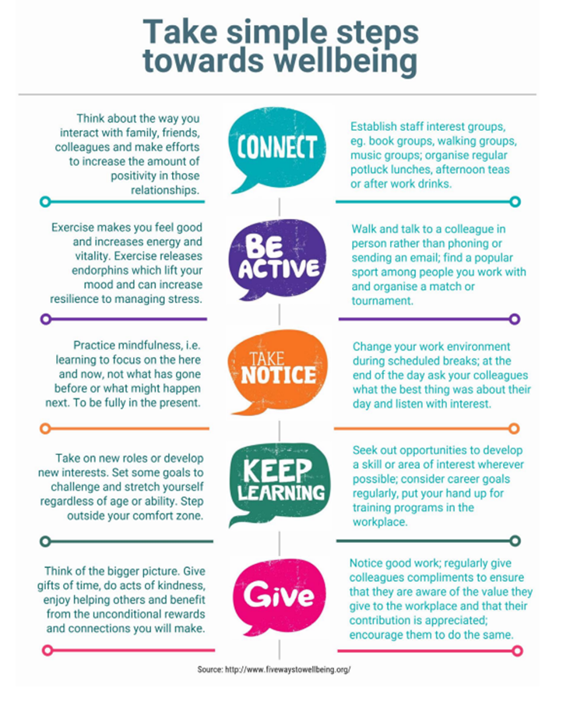

References:
Employer Guide to Family and Domestic Violence (fairwork.gov.au)
black-dog-institute-mental-health-toolkit-2017.pdf (blackdoginstitute.org.au)
95ede608683e1891aeef950f0e6cb98f_Blueprint_for_Mentally_Healthy_Workplaces.pdf (amazonaws.com)
Developing a workplace mental health strategy - A how-to guide for organisations (headsup.org.au)
Small-business-owners-guide-to-creating-a-mental-health-plan_1.pdf (vsbc.vic.gov.au)
Disclosure of mental health difficulties | headspace
Responding-to-disclosures-of-mental-health-issues.pdf (headspace.org.au)

